製作JSTL DB sql標籤的使用(2)
1. C:\apache-tomcat-9.0.24\webapps\ROOT\WEB-INF下建立lib資料夾
2. C:\apache-tomcat-9.0.24\webapps\ROOT\WEB-INF\lib資料夾內加入JSTL類別庫jstl-api.jar , jstl-impl.jar 及 資料庫類別庫 mysql-connector-java-8.0.19.jar
3. C:\apache-tomcat-9.0.24\webapps\ROOT內新增 MyUpdate.jsp 修改資料表

<%@ taglib uri="http://java.sun.com/jsp/jstl/core" prefix="c"%>
<%@ taglib uri="http://java.sun.com/jsp/jstl/sql" prefix="sql"%>
<html>
<head>
<title>Update Operation</title>
</head>
<body>

<sql:setDataSource var="sample" driver="com.mysql.cj.jdbc.Driver"
url="jdbc:mysql://localhost:3306/classicmodels?serverTimezone=CST"
user="root" password="1234"/>

<c:set var="empId" value="104"/>
<c:set var="testData" value="Hello"/>

<sql:update dataSource="${sample}" var="count">
update myEmployees set lastname ='${testData}' where ID= ${empId}
</sql:update>

<sql:query dataSource="${sample}" var="result">
SELECT * from myEmployees
</sql:query>

<table border="1" width="100%">
<tr>
<th>Emp ID</th>
<th>First Name</th>
<th>Last Name</th>
<th>Age</th>
</tr>
<c:forEach var="row" items="${result.rows}">
<tr>
<td><c:out value="${row.id}"/></td>
<td><c:out value="${row.firstname}"/></td>
<td><c:out value="${row.lastname}"/></td>
<td><c:out value="${row.age}"/></td>
</tr>
</c:forEach>
</table>
</body>
</html>
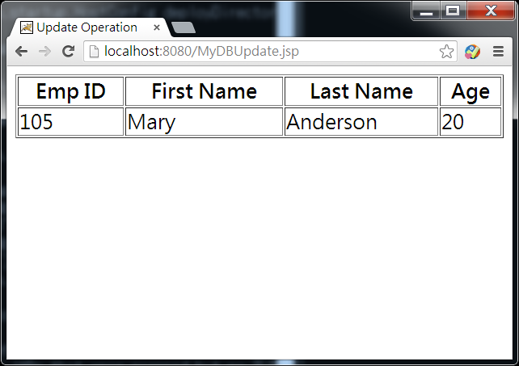
4. C:\apache-tomcat-9.0.24\webapps\ROOT內新增 MyDBDelete.jsp 刪除資料列

<%@ taglib uri="http://java.sun.com/jsp/jstl/core" prefix="c"%>
<%@ taglib uri="http://java.sun.com/jsp/jstl/sql" prefix="sql"%>

<html>
<head>
<title>DELETE Operation</title>
</head>
<body>

<sql:setDataSource var="sample" driver="com.mysql.cj.jdbc.Driver"
url="jdbc:mysql://localhost:3306/classicmodels?serverTimezone=CST"
user="root" password="1234"/>

<c:set var="empId" value="105"/>

<sql:update dataSource="${sample}" var="count">
DELETE FROM myEmployees WHERE Id = ?
<sql:param value="${empId}" />
</sql:update>

<sql:query dataSource="${sample}" var="result">
SELECT * from myEmployees
</sql:query>

<table border="1" width="100%">
<tr>
<th>Emp ID</th>
<th>First Name</th>
<th>Last Name</th>
<th>Age</th>
</tr>
<c:forEach var="row" items="${result.rows}">
<tr>
<td><c:out value="${row.id}"/></td>
<td><c:out value="${row.firstname}"/></td>
<td><c:out value="${row.lastname}"/></td>
<td><c:out value="${row.age}"/></td>
</tr>
</c:forEach>
</table>

</body>
</html>

